Contour Detection
Code:
import cv2
import numpy as np
from matplotlib import pyplot as plt
image = cv2.imread('flow.jpg')
gray = cv2.cvtColor(image, cv2.COLOR_BGR2GRAY)
blurred = cv2.GaussianBlur(gray, (5, 5), 0)
edges = cv2.Canny(blurred, 50, 150)
contours, _ = cv2.findContours(edges, cv2.RETR_EXTERNAL, cv2.CHAIN_APPROX_SIMPLE)
contour_image = image.copy()
cv2.drawContours(contour_image, contours, -1, (0, 255, 0), 2)
plt.figure(figsize=(10, 5))
plt.subplot(1, 3, 1)
plt.title('Original Image')
plt.imshow(cv2.cvtColor(image, cv2.COLOR_BGR2RGB))
plt.axis('off')
plt.subplot(1, 3, 2)
plt.title('Edges Detected')
plt.imshow(edges, cmap='gray')
plt.axis('off')
plt.subplot(1, 3, 3)
plt.title('Contours')
plt.imshow(cv2.cvtColor(contour_image, cv2.COLOR_BGR2RGB))
plt.axis('off')
plt.tight_layout()
plt.show()

Code explations:
1. Image Loading
image = cv2.imread('flow.jpg')
This line reads the input image file flow.jpg. The image is loaded in BGR (Blue-Green-Red) color format by default.

2. Converting to Grayscale
gray = cv2.cvtColor(image, cv2.COLOR_BGR2GRAY)
The loaded color image is converted to grayscale. Grayscale simplifies processing by focusing only on intensity values, eliminating the complexity of color data.

3. Reducing Noise
blurred = cv2.GaussianBlur(gray, (5, 5), 0)
Gaussian Blur smooths the image by applying a Gaussian kernel. This reduces high-frequency noise, such as random pixel variations, which can interfere with edge detection. The (5, 5) kernel size specifies the size of the neighborhood used for blurring.

4. Edge Detection
edges = cv2.Canny(blurred, 50, 150)
The Canny edge detection algorithm identifies edges based on intensity gradients in the image.
- The first threshold (50) determines weak edges, and the second (150) identifies strong edges. Edges between these thresholds are included if they connect to a strong edge.

5. Finding Contours
contours, _ = cv2.findContours(edges, cv2.RETR_EXTERNAL, cv2.CHAIN_APPROX_SIMPLE)
Contours are detected from the edge-detected image.
- cv2.RETR_EXTERNAL retrieves only the outermost contours, ignoring any nested ones.
- cv2.CHAIN_APPROX_SIMPLE compresses the contours by keeping only essential points, reducing memory usage.

6. Drawing Contours
cv2.drawContours(contour_image, contours, -1, (0, 255, 0), 2)
Contours are drawn on a copy of the original image.
- -1 indicates that all detected contours should be drawn.
- (0, 255, 0) specifies green as the contour color in BGR format.
- 2 sets the thickness of the contour lines.

7. Displaying the Results
plt.figure(figsize=(10, 5))

plt.subplot(1, 3, 1)
plt.title('Original Image')
plt.imshow(cv2.cvtColor(image, cv2.COLOR_BGR2RGB))
plt.axis('off')

plt.subplot(1, 3, 2)
plt.title('Edges Detected')
plt.imshow(edges, cmap='gray')
plt.axis('off')

plt.subplot(1, 3, 3)
plt.title('Contours')
plt.imshow(cv2.cvtColor(contour_image, cv2.COLOR_BGR2RGB))
plt.axis('off')

plt.tight_layout()
plt.show()
The results are displayed using Matplotlib:
- Original Image: Displays the input image as a reference.
- Edges Detected: Shows the output from the Canny edge detector in grayscale.
- Contours: Displays the original image with the detected contours drawn.

output:
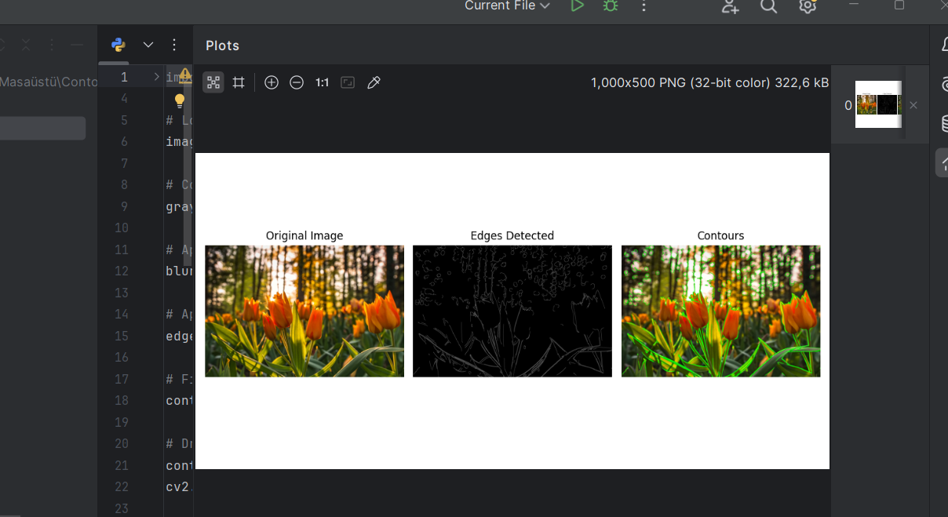

Report
Objective
The purpose of this code is to detect contours in an image, specifically flow.jpg. Contours are useful for object detection, shape analysis, and image segmentation.
Methodology
- Image Loading and Preprocessing
  - The image is loaded in color mode.
  - Converted to grayscale to simplify processing by removing color information.
  - Gaussian Blur is applied to reduce noise, ensuring smoother edge detection.
- Edge Detection
  - Canny edge detection is employed with thresholds of 50 and 150 to highlight edges in the image.
- Contour Detection
  - Contours are extracted using cv2.findContours with the RETR_EXTERNAL mode, capturing only the external contours.
  - CHAIN_APPROX_SIMPLE reduces the number of points defining contours, optimizing memory usage.

- Visualization
  - The results are displayed using Matplotlib: the original image, the edge-detected image, and the contours overlaid on the original.
Results
- Edge Detected Image: Shows prominent edges in the image.
- Contours Image: Highlights the detected contours, visually verifying the process.
Applications
This approach is applicable in areas like:
- Shape analysis for industrial quality control.
- Object detection in autonomous navigation.
- Image segmentation in medical imaging.

